Name: Richard Raymond J. Canda

C.Y.S.: BSCpE - 3A

**VHDL CODE FOR D FLIP FLOP:**

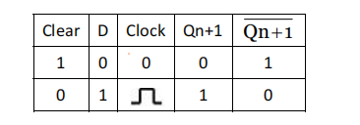

library IEEE;

use IEEE.STD_LOGIC_1164.ALL;

entity D_flipflop is

Port (

d : in STD_LOGIC;

clk : in STD_LOGIC;

res_n : in STD_LOGIC; -- active-low reset

q : out STD_LOGIC

);

end D_flipflop;

architecture Behavioral of D_flipflop is

begin

process(clk)

begin

if rising_edge(clk) then

if res_n = '' then

q <= 'a';

else

q <= d

s;

end if;

end if;

end process;

end Behavioral;

